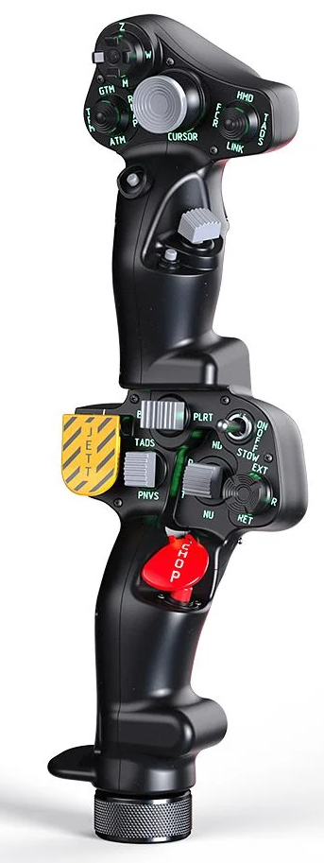  1xx - Controls | 2xx - Ground | 3xx - Flight | 4xx - A2A | 5xx - A2G | 6xx - Misc
102 - Controls - Pilot - Collective Grip Apache-64
U=Up, D=Down, F=Forward, B=Backward, L=Left, R=Right, P=Press, S-*=Shift-*, L-*=Long-*

Top Trigger
- P: Alternate Cursor enter
FCR Scan Size hat (top)
- U: FCR Scan Size Zoom (15 deg arc)
- D: FCR Scan Size Medium (45 deg arc)
- R: FCR Scan Size Wide (90 deg arc)
- L: FCR Scan Size Narrow (30 deg arc)
- P: Chaff
FCR Mode hat (left)
- U: FCR GTM (Ground Target Mode)
- D: FCR ATM (Air Target Mode)
- R: FCR RMAP (Radar Map mode)
- L: FCR TPM (Terrain Profiles Mode)
- P: --
Sight Select hat (right)
- U: Sight Select HMD (IHADSS)
- D: Sight Select LINK (sets FCR or TADS to LOS of TADS or FCR, depending on which is selected)
- L: Sight Select FCR
- R: Sight Select TADS (not active in pilot's station)
- P: --
Cursor hat (Ministick)
- Axes: Cursor controller
- P: Cursor enter
- S-P: Cursor Display Select button (toggles cursor between MFDs)
Cursor Select button (under ministick)
- P: FCR Scan switch forward (S-SCAN, single sweep)
- S-P: FCR Scan switch back (C-SCAN, continuous scanning)
FCR Scan switch (thumb) -- Comms
- F: (SRS radio 1 PTT)
- B: (SRS radio 2 PTT)
- P: (VoiceAttack PTT)
- S-P: (VoiceAttack center mouse cursor)
Cued Search button (under thumb switch)
- P: FCR Cued Search button (slew FCR to detected emitter)
Top Pinky button
- P: Parking brakes (toggle)
- S-P: Tail Wheel lock/unlock
-------------------------------------------------------------------------------------------------------------------------------------
Bottom trigger
- P: --
Boresight rocker
- L: Boresight/Polarity switch PLRT (toggles FLIR polarity; switch to B/S is no function)
- P: --
- R: --
Searchlight switch
- F: Searchlight switch ON
- B: Searchlight switch OFF
- B and Hold: Searchlight switch STOW
Searchlight hat
- U/D/L/R: Searchlight up/down/left/right
- P: --
Jettison button
- P: Emergency Jettison Guard OPEN
- P and Hold: Emergency Jettison Switch Depress
NVS switch
- F: NVS Select switch TADS
- P: --
- B: NVS Select switch PNVS
- S-F: NVS mode switch up (OFF -> NORM -> FIXED)
- S-B: NVS mode switch down (FIXED -> NORM -> OFF)
Stabilator switch
- F: Stabilator Control nose down
- P: Stabilator Control auto mode (also disables NOE/A mode if active)
- B: Stabilator Control nose up
Chop button
- P: --
- P and Hold: --
Bottom Pinky button
- P: Parking brakes (toggle)
- S-P: Tail Wheel lock/unlock

